**Ideation Phase**

**Empathize & Discover**

|  |  |
| --- | --- |
| **Date** | 15th June 2025 |
| **Team ID** | LTVIP2025 TMID35397 |
| **Project Name** | Revolutionizing Liver Care : Predicting Liver Cirrhosis Using Advanced Machine Learning Techniques |
| **Maximum Marks** | 4 Marks |

**Empathy Map Canvas: Revolutionizing Liver Care**  
**Predicting Liver Cirrhosis Using Advanced Machine Learning Techniques**

An empathy map is a simple, visual tool that captures deep insights about a patient's behaviors, emotions, needs, and challenges—especially those at risk of or suffering from liver cirrhosis.

In the context of our project, the empathy map helps our team better understand patients, healthcare providers, and caregivers involved in liver disease care. Creating an effective AI-driven prediction system requires not only technical precision but also a strong understanding of the real-world problems faced by those living with or managing liver cirrhosis.

By building this empathy map, we step into the shoes of our users—patients, doctors, and healthcare administrators—to explore their goals, frustrations, concerns, and needs. This ensures that our machine learning solution is designed with compassion, usability, and clinical relevance at its core.

**Revolutionizing Liver Care: Predicting Liver Cirrhosis Using Advanced Machine Learning Techniques**

Liver disease, particularly cirrhosis, is becoming an increasingly critical global health concern. Factors such as unhealthy lifestyles, late diagnoses, and limited access to specialized care contribute to a rising number of cirrhosis cases. Early detection and timely intervention are key to preventing complications and improving patient outcomes.

To address this challenge, the integration of Artificial Intelligence and Machine Learning (AI/ML) offers a promising solution. By analyzing vast amounts of patient data—including clinical records, lab results, and medical history—machine learning models can identify patterns that indicate the early stages of liver cirrhosis. These models not only help in predicting the risk of cirrhosis but can also assist in flagging high-risk individuals before symptoms become severe.

Hence, there is a strong need to develop accurate and efficient ML algorithms capable of predicting liver cirrhosis with a high degree of precision. These models must minimize prediction errors and align closely with real-world clinical data to ensure reliability. By doing so, we can empower healthcare providers with early alerts and data-driven insights, ultimately transforming the future of liver care and saving lives.

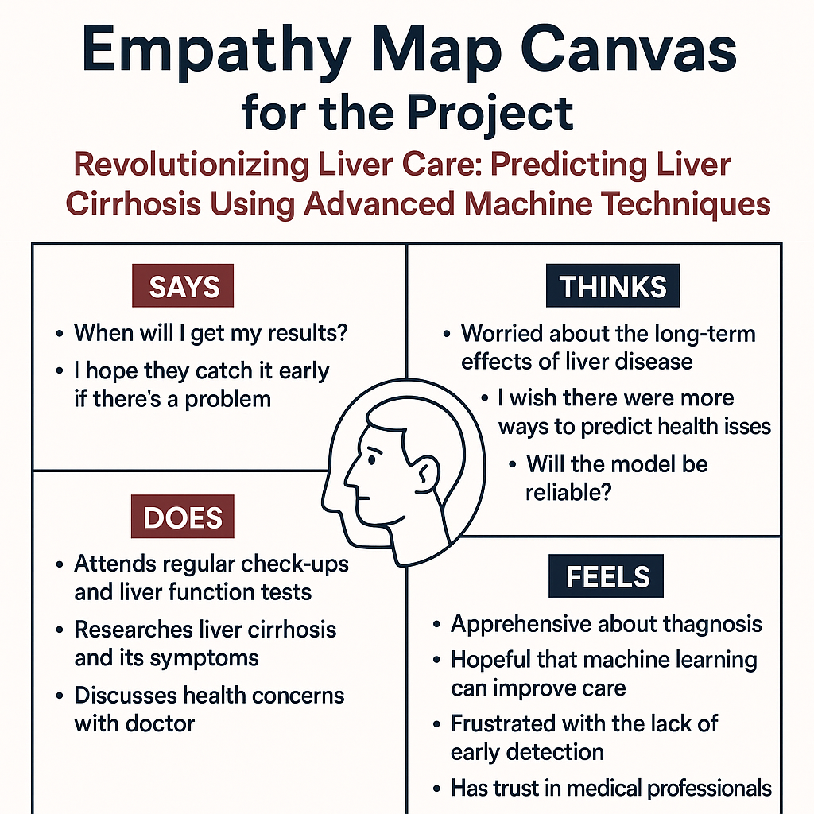

**Empathy Canvas Map for the Project**